[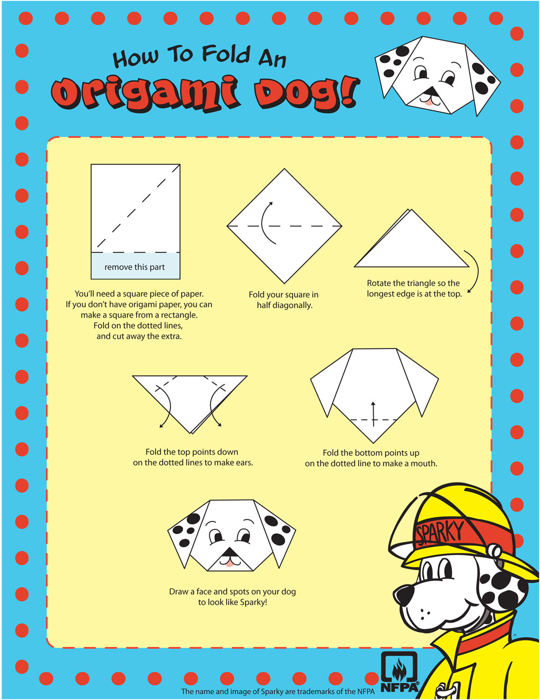](http://www.sparky.org/mobile/gallery/activities/origamiDog.jpg)

www.Sparky.org